*`*

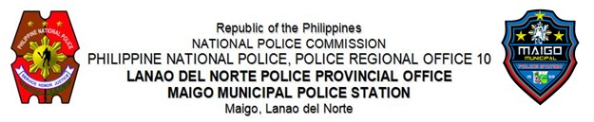

**MEMORANDUM**

FOR : **PCOL ROY A MAGSALAY**

Provincial Director, Lanao del Norte PPO

Camp Gallego, Pigcarangan, Tubod, LDN

(ATTN: C, PIDMU)

FROM : Officer in-Charge, Maigo MPS

SUBJECT : **Letter From Commander, Fleet Provost Marshal, Philippine Navy**

DATE : December 13, 2024

1. References:
   1. Memorandum from C, RIDMD dated December 12, 2024 with subject same as above; and
   2. b. Memorandum from TADIDM dated December 12, 2024.and Standard operating procedure.
2. This pertains to the letters from Commander Resuello, requesting assistant in implementing the alarm for the apprehension of Fireman Second Class (FN2) Paulo D. Rivera, FN2 Renan N. Gonzales, FN2 Marciano P. Abiul II, and FN2 Nhilbert John T. Mendrez.

1. In this regard, At around 7:00 in the morning of December 13, 2024, Personnel from this station under the direct supervision of PCPT RODELIO G DIEZ OIC, conducted inquiry for the possible identification and apprehension of the abovementioned Navy Personnel.

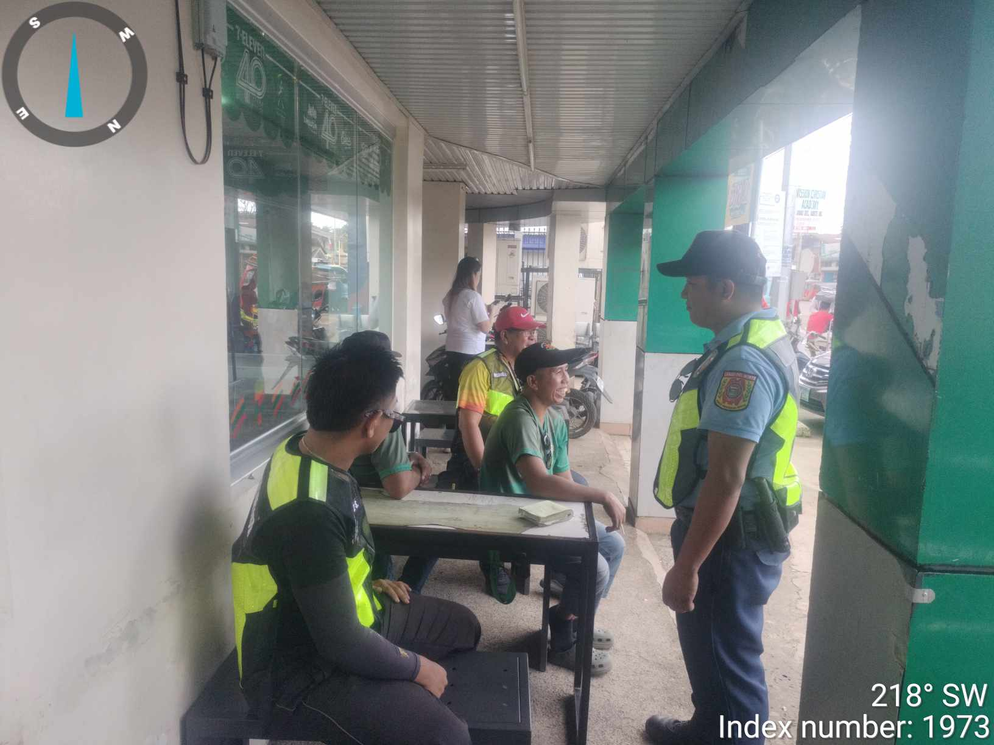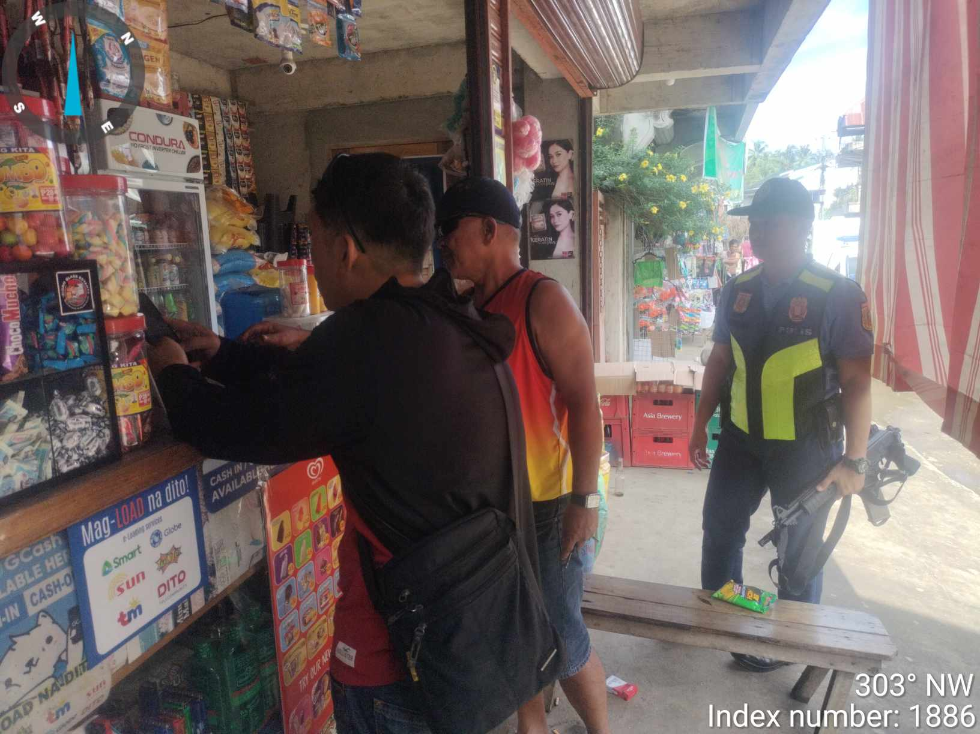

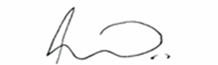

**PCPT RODELIO G DIEZ**

Officer In Charge